PROGRAMMING II

**Exercise 1 (OOP)**

Example 1 – Bird

Properties:

1. Type

2. Colour

3. Size

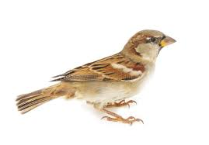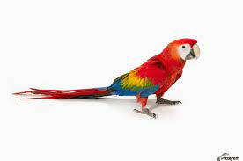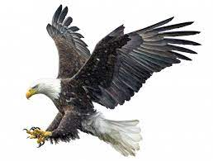

Type: Sparrow

Colour: Brown

Size: Small

Type: Parrot

Colour: Red, yellow, blue

Size: Medium

Type: Eagle

Colour: Black, white

Size: Big

Behavior:

1. Fly

2. Eat

3. Sleep

Class: Bird

Example 2 – Battery

Properties:

1. Brand

2. Voltage

3. Size

Class: Battery

Behavior:

1. Provide energy

2. Convert energy to electrical

3. Store energy

Brand: Panasonic

Voltage: 1.5 volts

Size: AA

Brand: Energizer

Voltage: 4.5 Volts

Size: 3LR12

Brand: Duracell

Voltage: 12 volt

Size: A23

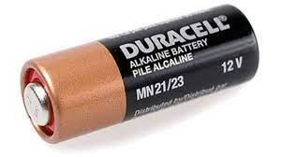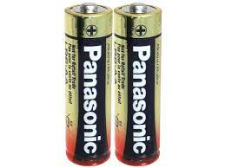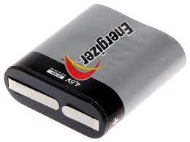

Example 3 – Bottle

Properties:

1. Brand

2. Material

3. Shape

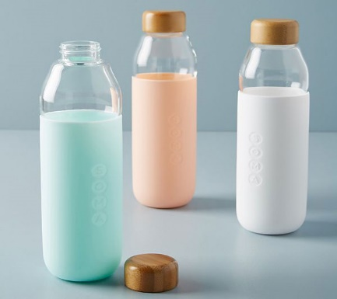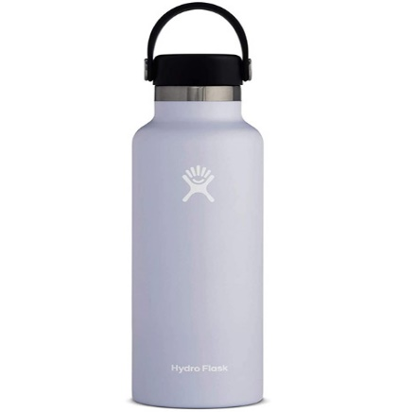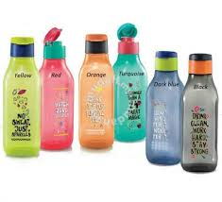

Brand: Soma

Material: Glass

Shape: Cylinder

Brand: Hydro Flask

Material: Steel

Shape: Cylinder

Brand: Tupperware

Material: Plastic

Shape: Rectangle

Behavior:

1. Keep liquid

2. Measure liquid level

3. Easy to carry

Class: Bottle

Example 4 – Cat

Properties:

1. Breed

2. Colour

3. Size

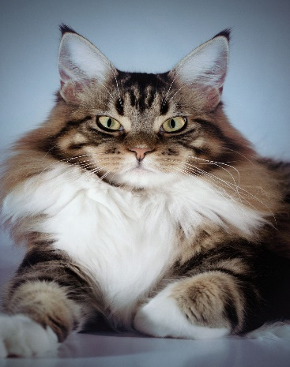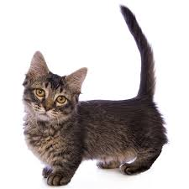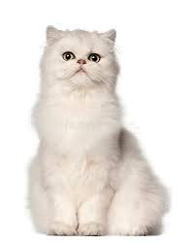

Breed: Maine Coon

Colour: Brown, white

Size: Big

Breed: Munchkin

Colour: Black, white

Size: Small

Breed: Persian

Colour: White

Size: Medium

Behavior:

1. Eating

2. Sleeping

3. Run

4. Climbing

Class: Cat

Example 5 – Watch

Properties:

1. Type

2. Material

3. Brand

Class: Watch

Behavior:

1. Identify time

2. Set alarm

3. Set timer

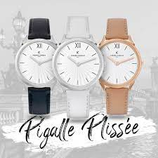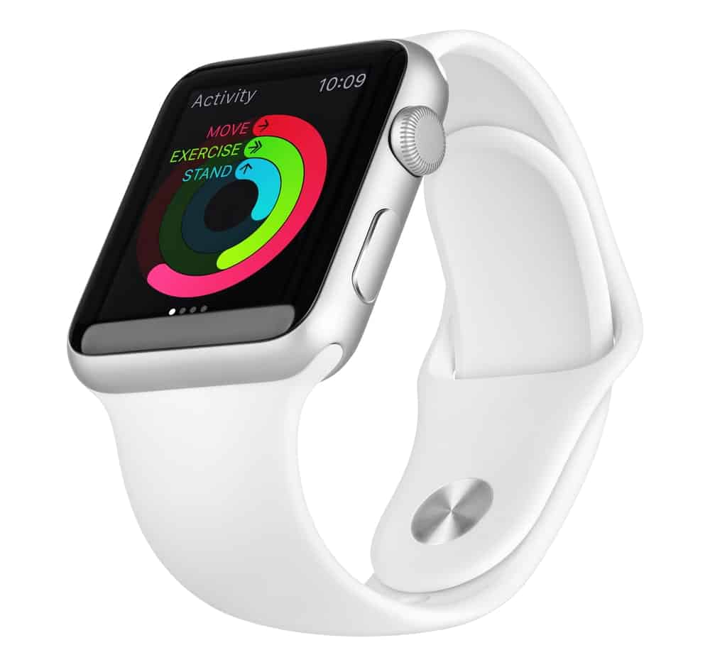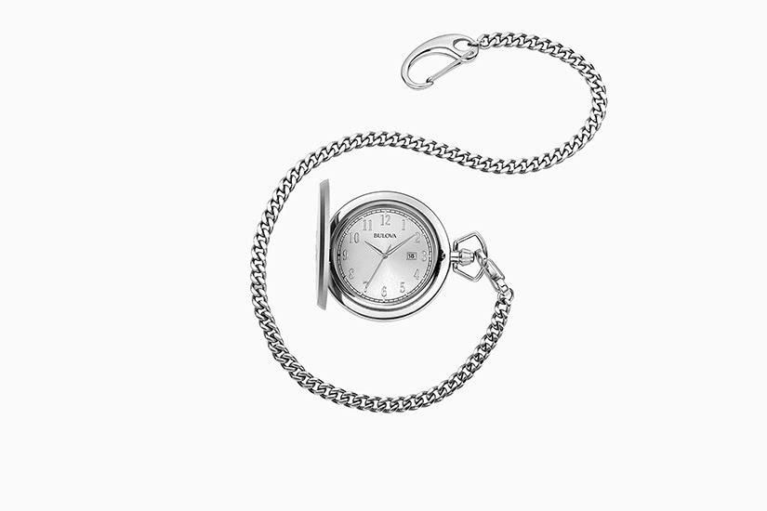

Type: Wrist watch

Material: Leather

Brand: Pierre Cardin

Type: Smart watch

Material: Rubber

Brand: Apple

Type: Pocket watch

Material: Steel

Brand: Bulova